Jefferson Park Forward Pub Crawl

Contact:
Ryan Richter,
President
Jefferson Park Forward
ryan@jeffersonparkforward.org
773.272.2343

FOR MORE INFORMATION: www.jeffersonparkforward.org/jpf-pub-crawl
April 10, 2017 – On Saturday, April 8, 2017, Jefferson Park Forward drew more than 80 members, neighbors and friends to its second annual JPF Pub Crawl. More than doubling last year’s attendance, revelers visited five local establishments on Milwaukee Avenue. The event raised more than $1,700 for Jefferson Park Forward, and sold $520 in 50/50 raffle tickets to benefit Chicago Canine Rescue. The lucky winner of the raffle was Marilyn Davis, a 30-year Jefferson Park resident, who promptly and generously gave her half of the pot back to Chicago Canine Rescue.
Special thanks to Babe’s on Milwaukee for sponsoring the event’s official mugs and hosting. Thanks also to Hops & Barley, Jefferson Inn, Rex Tavern and Windsor Bar and Grill for hosting.
To learn more about Jefferson Park Forward, join our monthly general meeting on Thursday, April 20, 7:00 p.m. at Anemone Creative, 5483 N. Northwest Highway, Chicago 60630, with social and networking hour to follow. Visit us online at www.jeffersonparkforward.org for more details.
Photo credit: Jefferson Park Forward
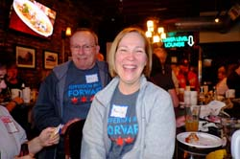
- Marilyn Davis celebrates her raffle win before donating her winnings back to Chicago Canine Rescue.

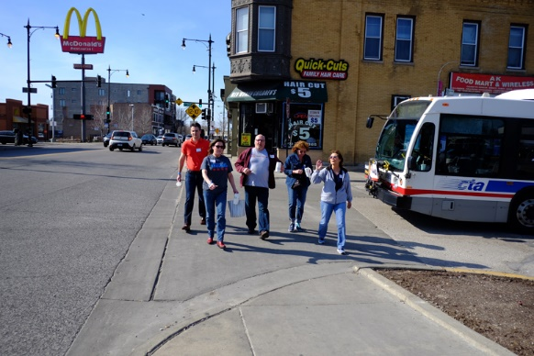
- JPF revelers walking between Rex Tavern and Windsor Tavern and Grill

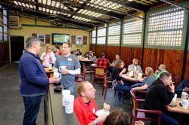

- JPF takes over the back patio at Windsor Tavern and Grill during the middle of its Pub Crawl

About Jefferson Park Forward:
Jefferson Park Forward is a new neighborhood organization in Jefferson Park whose mission is to support and revitalize the community. Through a commitment to supporting neighborhood events, highlighting local businesses and attractions, along with fundraising in support of local charities, Jefferson Park Forward seeks to be a voice for positive change throughout the community. To learn more about Jefferson Park Forward, please visit www.jeffersonparkforward.org.

